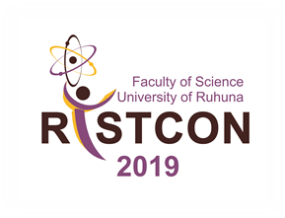

“Advancements in Multidisciplinary Scientific Research Toward Environmental Sustainability”
RISTCON 2023

10th Ruhuna International Science and Technology Conference -2023
Faculty of Science, University of Ruhuna, Wellamadama, Matara, Sri Lanka
2023
AD form

Author Declaration Form for Camera Ready Submission

- Abstract No: …………………………………………………………………………………..
- Title of the Abstract: ……………………………………………………………………………
…………………………………………………………………………………………………….
- Details of the corresponding author:
Name:
E-mail address:
Contact phone numbers: Office: Mobile:
- Declaration by all authors
I /We, the undersigned, declare that the work submitted for RISTCON 2023 has not been published, submitted for publication in any journal or presented at a scientific meeting before and that I/we have carefully read and approved the camera-ready version of the submitted abstract.
Note That: All authors must place their signature/scan signature/digital signature in order to publish/present in RISCON 2023.

Name | Official Address | Signature | Date

